Name: ____________________________

Date: ________________

Biology Diagnostic

This is a test to see how well you can use your science skills. Please take your time and answer to the best of your ability. This will not count against you in any way and is simply a way for me to see what you know. Do your best!

1.) What is ¾ as a percentage?
- 75%
- 25%
- 50%
- 100%

2.) What is 25% as a fraction?
- ¾
- ¼
- 1
- ½

3.) About how long is this line:
- 1 ft
- 6 in
- 5 cm
- 12 ml

4.) Choose the best tool(s) to measure the speed of an object.
- Ruler
- Graduated cylinder
- Triple beam balance
- Stopwatch

5.) What is the temperature on this thermometer?

a.) 60.8º
- 68 º
- 72 º
- 66 º

6.) Make a graph on the lines below using the information in this paragraph and on the table below:
On day 1, three male and three female fruit flies were placed in a flask that contained some food. No other flies were added or removed during the course of this experiment. Create a graph (using the data on the left) that shows the number of living fruit flies in the flask over a period of 70 days.

 | 
  Day # | Population of flies
  0 | 6
  7 | 12
  16 | 38
  19 | 50
  25 | 81
  33 | 200
  37 | 275
  43 | 310
  49 | 340
  55 | 341
  61 | 340
  70 | 341

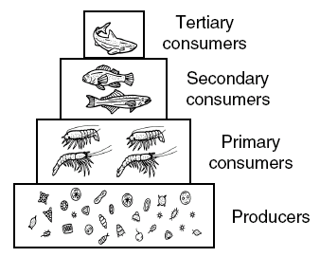
7.) According to the diagram, which level has the greatest number of different types of organism?
- Producers
- Primary consumers
- Secondary consumers
- Tertiary consumers

8.) According to the table, how many different bird species, on average, can be found in a coniferous forest?

Habitat | Productivity  (g/m²/yr) | Bird Diversity  (average number of species/km²)
Marsh | 2000 | 14
Grassland | 500 | 12
Shrub land | 600 | 8
Desert | 70 | 3
Coniferous forest | 800 | 17
Upland deciduous forest | 1000 | 21
Floodplain deciduous forest | 2000 | 24

- 800
- 17
- 14
- floodplain deciduous forest

13.) You are measuring the height of plants in an experiment. You are growing 6 plants. On the tenth day of the experiment you measure them and discover that they have the following heights: 7 cm, 10cm, 12cm, 5cm, 8cm, and 14cm. What is the average height of these plants?
- 9.3 cm
- 8.1 cm
- 11.2 cm
- 56 cm
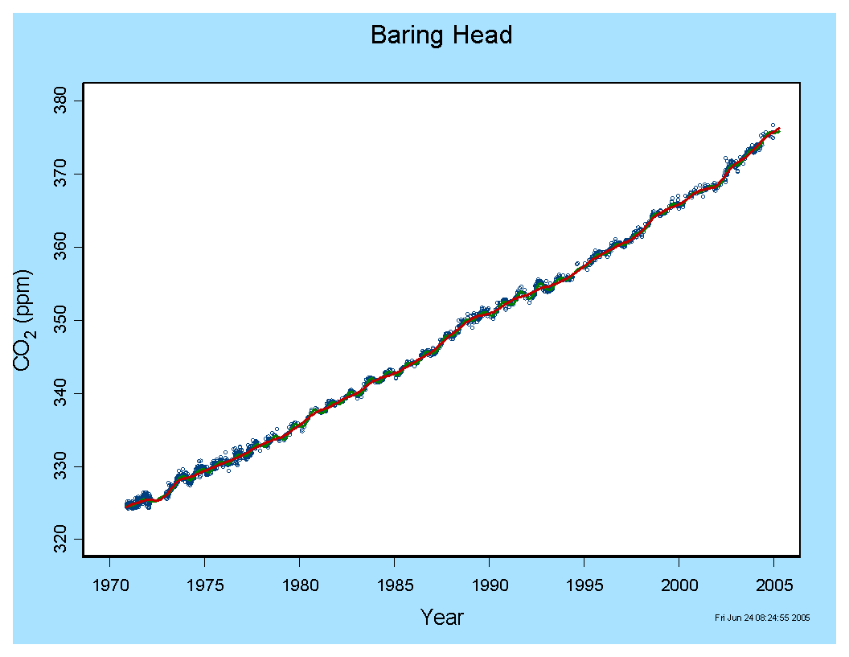

9.) According to the graph, how much CO₂ was there in the atmosphere in 1995?
- 330 ppm
- 342 ppm
- 350 ppm
- 360 ppm

10.) In an experiment, a hypothesis is…
- an educated guess about the outcome of the experiment
- the data being collected during the experiment
- the question being asked in the experiment
- the background research before an experiment

11.) In an experiment what is the control group if we are testing the effects of music on bean plant growth?
- heavy metal music
- plant height
- no music
- the bean plant
12.) What is the procedure in an experiment?
- The question being asked
- The steps taken to perform the experiment
- The information collected
- An educated guess

Directions: Read the following passage and answer questions 13-15.

Has Genetic Engineering Gone Too Far?

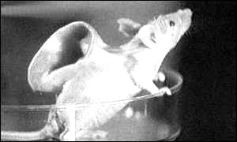
What do you get when you cross a sheep with a human? That sounds like a joke, but the question is no laughing matter: it's serious science. The result, a chimera, is an animal with cells from another animal. Recently, Esmail Zanjani, a scientist at the University of Nevada, announced he had created sheep with 15 percent human cells. His goal is to create partly human organs for people who need transplants.
The word chimera comes from a mythical Greek beast with a lion's head, a goat's body, and a snake's tail. Skeptics say that the prospect of growing human spare parts in sheep is still a distant dream. Modern cloning techniques, however, have allowed scientists to enter uncharted and, some people say, dangerous territory.
Sen. Sam Brownback (R-Kan.) fears that mixing human and animal genetic material could create new diseases. Dr. Patrick Dixon, a lecturer on biological trends, worries that new viruses could be a "biological nightmare" for humans. Rather than creating new diseases, researchers argue, chimeras may help reveal the cures to existing illnesses. Experimental drugs, which cannot be tested on humans, could be tested on chimeras to try to treat those diseases, he says.

13.) What is the science definition of a chimera?
- an animal with cells from another animal
- a mythical Greek beast with a lion’s head, a goat’s body, and a snake’s tail
- a clone
- a disease resulting from the mixing of animal and human DNA
14.) What is one potential problem with using chimeras in science?
- chimeras could create new diseases
- experimental drugs could be tested on chimeras
- chimeras could help cure illnesses
- sheep could mix with humans

15.) Based on the language used in the article, what is the author’s position on chimeras?
- the author is against the use of chimeras because they can cause new diseases.
- the author supports the use of chimeras because the advantages of chimeras were the last issue discussed in the article.
- the author has no opinion on chimeras.
- the author wants people to think about the advantages and disadvantages of using chimeras.

Directions: In this next section, tell me what you think! I want to know what comes to your mind when I ask you these questions. Remember, you will not be judged on being correct, this is just so I can understand what you already know.

16.) Where does rain come from?

17.) How do plants get energy?

19.) Why do we have seasons?

20.) What makes a tree?

21.) What is the scientific method?

